**Retrieve Container Data in Windows 8 Apps**

Step 1: Create storage.

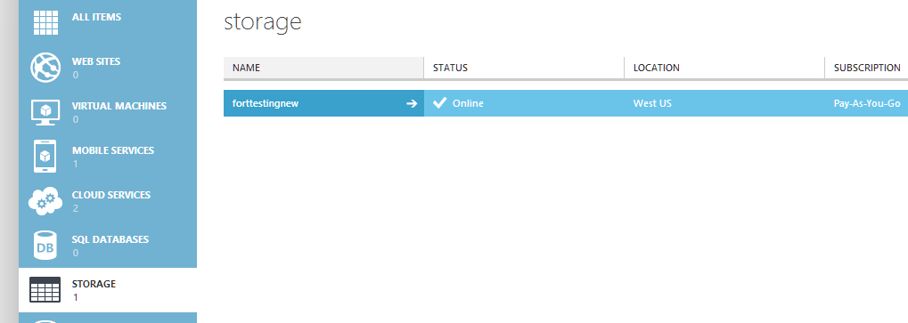

Step 2: Create Container. Set to Public Container.

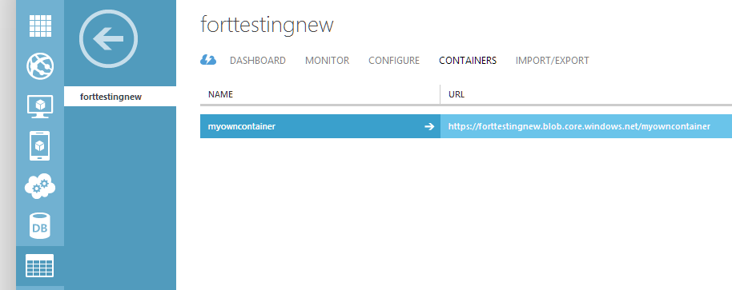

Upload the Images using Azure Storage Explorer tool or app.

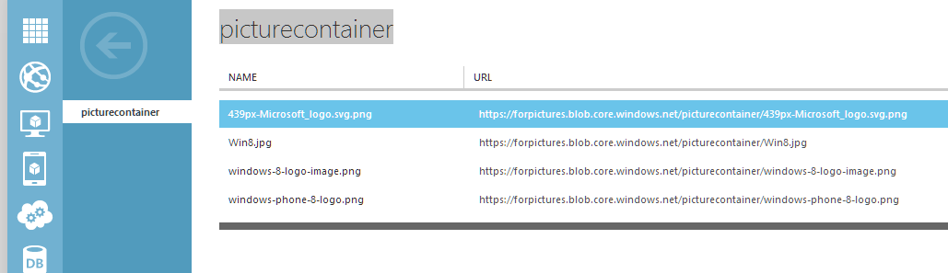

Step 3: Start Visual Studio Create Windows 8 New XAML/ C# App.

Right click on “References” & select “Manage NuGet Packages…”

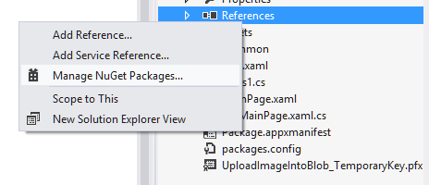

Enter the term for search “Windows Azure Storage”

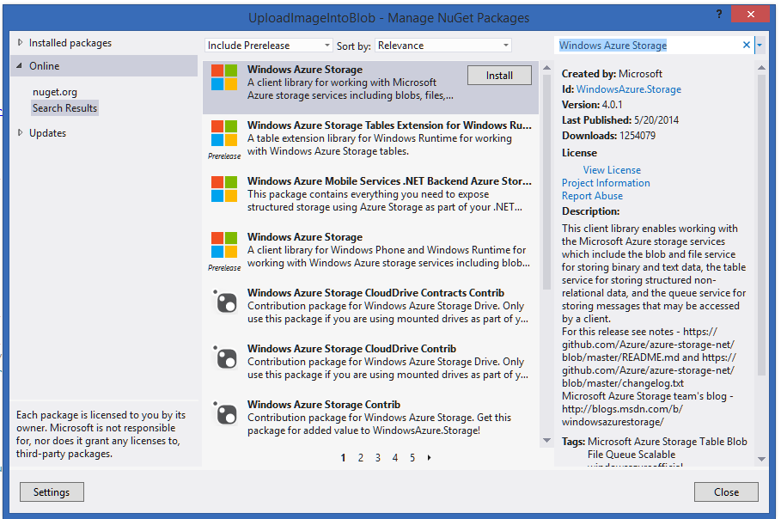

Step 4: after installation Windows Azure Storage Package or DLL added to the App.

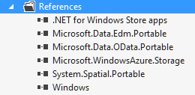

Step 5: Open MainPage.xaml file

<Grid Background="{StaticResource ApplicationPageBackgroundThemeBrush}">

<ListBox x:Name="myListBox">

<ListBox.ItemTemplate>

<DataTemplate>

<StackPanel Orientation="Horizontal">

<TextBlock Text="{Binding}" Height="200" Width="1000"/>

<Image Source="{Binding}" Height="100" Width="100"/>

</StackPanel>

</DataTemplate>

</ListBox.ItemTemplate>

</ListBox>

</Grid>

Step 6: Open MainPage.xaml.cs file

Add few references

using Microsoft.WindowsAzure.Storage;

using Microsoft.WindowsAzure.Storage.Auth;

using Microsoft.WindowsAzure.Storage.Blob;

using System.Diagnostics;

protected async override void OnNavigatedTo(NavigationEventArgs e)

{

var credentials = new StorageCredentials("fortestingnew", "96OdFITud72q8RTfhsJeM1i1Yov8Qlrk9sXLBKOjh7FtOsxYV3klrScv7AE53R8keH9Ylj8JTbBSf177wBDjIw==");

var account = new CloudStorageAccount(credentials, true);

var blobClient = account.CreateCloudBlobClient();

var container = blobClient.GetContainerReference("myowncontainer");

await container.CreateIfNotExistsAsync();

BlobContinuationToken x = new BlobContinuationToken();

BlobResultSegment result = await container.ListBlobsSegmentedAsync(x);

List<string> dataSet = new List<string>();

foreach (var item in result.Results)

{

dataSet.Add(item.Uri.AbsoluteUri);

//Debug.WriteLine(item.Uri.AbsoluteUri);

}

myListBox.ItemsSource = dataSet;

//container.ListBlobsSegmentedAsync(string.Empty, true, Microsoft.WindowsAzure.Storage.Blob.BlobListingDetails.All, null, tokenSource);

}

Now run the App.

Retrieving the url & image.

